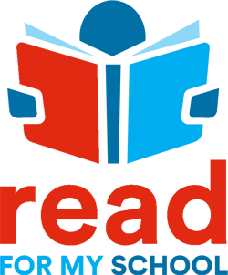

Dear Fundraising Supporters,

Hello and welcome to [FUNDRAISER NAME] sponsored by the PTA! We are extremely excited to offer a new and innovative approach to community fundraising that combines our love for reading while teaching the importance of giving back.

Starting [INSERT START DATE], the PTA is excited to announce a partnership to provide a digital reading challenge to our community called, Read for My School. Fast to setup and easy to use across any mobile device, Read for My School provides parents and students a fun and engaging way to share their love of reading while understanding the importance of giving back to our school.

Through your community support, we would like parents to read with their children and track their progress on the Read for My School web app. We would also love parents to share our reading challenge as well as their child’s reading achievements with friends and family to generate pledge donation support. With Read for My School, sharing with love ones is as simple as 1, 2, 3!

Here’s some of our fundraising objectives:
- To raise [INSERT FUNDRAISING GOAL] to support various program initiatives
- A school goal to read over [INSERT READING MINUTES] minutes
- A school goal to read over [INSERT BOOKS GOAL] books

As you can see, we’ve set some pretty lofty reading and fundraising goals and looking for your support to make our school reading challenge a successful one. So what are you waiting for? Let’s starting reading and fundraising today!

You will soon be receiving an email with an invitation to join our reading challenge. Just click on the invitation link and follow the steps to get your reader/s registered to their team and ready when our reading challenge starts.

We are extremely excited to share this opportunity and look forward to working with you in support of your PTA community’s commitment to raising funds to promote new school programs.

Sincerely,

[INSERT SCHOOL NAME]
[INSERT PTA CONTACT INFO]

