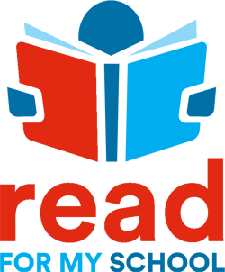

Dear [INSERT SCHOOL NAME] Staff,

Hello and welcome to Read for My School! We are extremely excited to partner with your school to offer a new and innovative approach to community fundraising that combines our love for reading while teaching the importance of giving back. Fast to setup and easy to use, Read for My School provides teachers, parents, and students a fun and engaging way to share their love of reading and giving back to your school.

As teachers, you can make your reading and fundraising challenge a success by following the simple steps below.

Your To-Do list:
- Register your account on Read for My School – You will receive an invite link to register for your reading and fundraising challenge. Registration takes just a couple of minutes. You will be asked to do the following:
  - Create a team name – Think of a fun name that your students will embrace (Example: Mr. Smith’s 3rd Grade Bookworms);
  - Create your team leader profile – Select an avatar and complete registration profile.
- Create a personal message for your donation page – All supporters have a donation page to share via SMS, Facebook, Twitter, and email so add a personal message that donors will see to promote your fundraiser;
- Set up custom reading goals – Set reading minutes and book goals for your team of readers on your My Fundraiser page. Just click the EDIT button and align goals to your class/grade level expectations;
- Invite your readers to join your team – Go to your My Team page and invite your parents and readers to join in on the fun! You can choose from our invite options so that your readers are ready to go when your challenge begins!

Have questions? Once you register, you can reach out to a support team member directly within the app or go to our RFMS toolkit from your profile menu. There you will find answers to your questions, downloadable resources, and training videos.

Sincerely,

Read for My School Support Team

